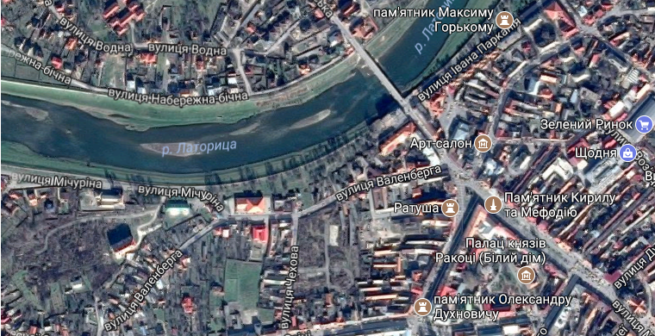

<!doctype html>

<html>

<head>

</head>

<body>

<h1> Карта Мукачево </h1>

<img src="Images/Map1.png" alt="Map" usemap="#Muckachevo">

<map name="Muckachevo">

<area shape="circle" coords="544,221,15" href="https://pmg.ua/life/44765-ploshhu-myru-u-mukachevi-pereymenuvaly-na-ploshhu-kyryla-i-mefodiya" alt="Площа миру" target="_blank">

<area shape="circle" coords="572,238,11" href="https://ua.igotoworld.com/ru/poi_object/74706_pamyatnik-svyatym-kirillu-i-mefodiyu.htm" alt="Пам*ятник Кирилу і Мифодію" target="_blank">

<area shape="rect" coords="432,231,522,276" href="https://uk.wikipedia.org/wiki/%D0%9C%D1%83%D0%BA%D0%B0%D1%87%D1%96%D0%B2%D1%81%D1%8C%D0%BA%D0%B0_%D1%80%D0%B0%D1%82%D1%83%D1%88%D0%B0" alt="Ратуша" target="_blank">

<area shape="poly" coords="4,108,145,147,345,123,451,60,494,15,532,24,475,98,404,152,244,199,41,175,4,161,5,110" href="https://ru.wikipedia.org/wiki/%D0%9B%D0%B0%D1%82%D0%BE%D1%80%D0%B8%D1%86%D0%B0" alt="Латориця" target="_blank">

<area shape="poly" coords="674,206,706,184,722,197,690,224" href="http://www.shodnya.com.ua/" alt="ТРЦ *Щодня*" target="_blank">

</body>

</html>